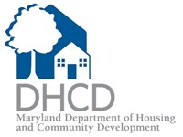

**Maryland Department of Housing and Community Development**

**Multifamily Housing Programs**

**TEFRA Public Hearing Notice Information Sheet**

**For Proposed Multifamily Rental Development**

|  |  |  |
| --- | --- | --- |
| **Project Information** | | |
| 1) Name of Project | | 2) Number of Residential Units |
| 3) Project Type (i.e. New Construction, Acq./Rehab.) | | 4) Project Occupancy (i.e, Senior, General Occupancy, Special Needs) |
| 5) Exact Street Address(es) of all Buildings in Project | | |
| 6) Full name of Borrower (example: XYZ Housing Limited Partnership) | | |
| 7) Amount of Tax-Exempt Financing Requested (Please use highest anticipated amount) | | |
| PART II | Contact Information | |
| 8) Name of Person Completing Form | | |
| 9) Phone | | 10) Company and Address |
| 11) Email | | |
| 12) Date | | |

Return completed form by email to:

Diane Melton

Maryland DHCD

[Diane.Melton@Maryland.gov](mailto:Diane.Melton@Maryland.gov)

301-429-7710